Implementation Of Queue Using Linked List.
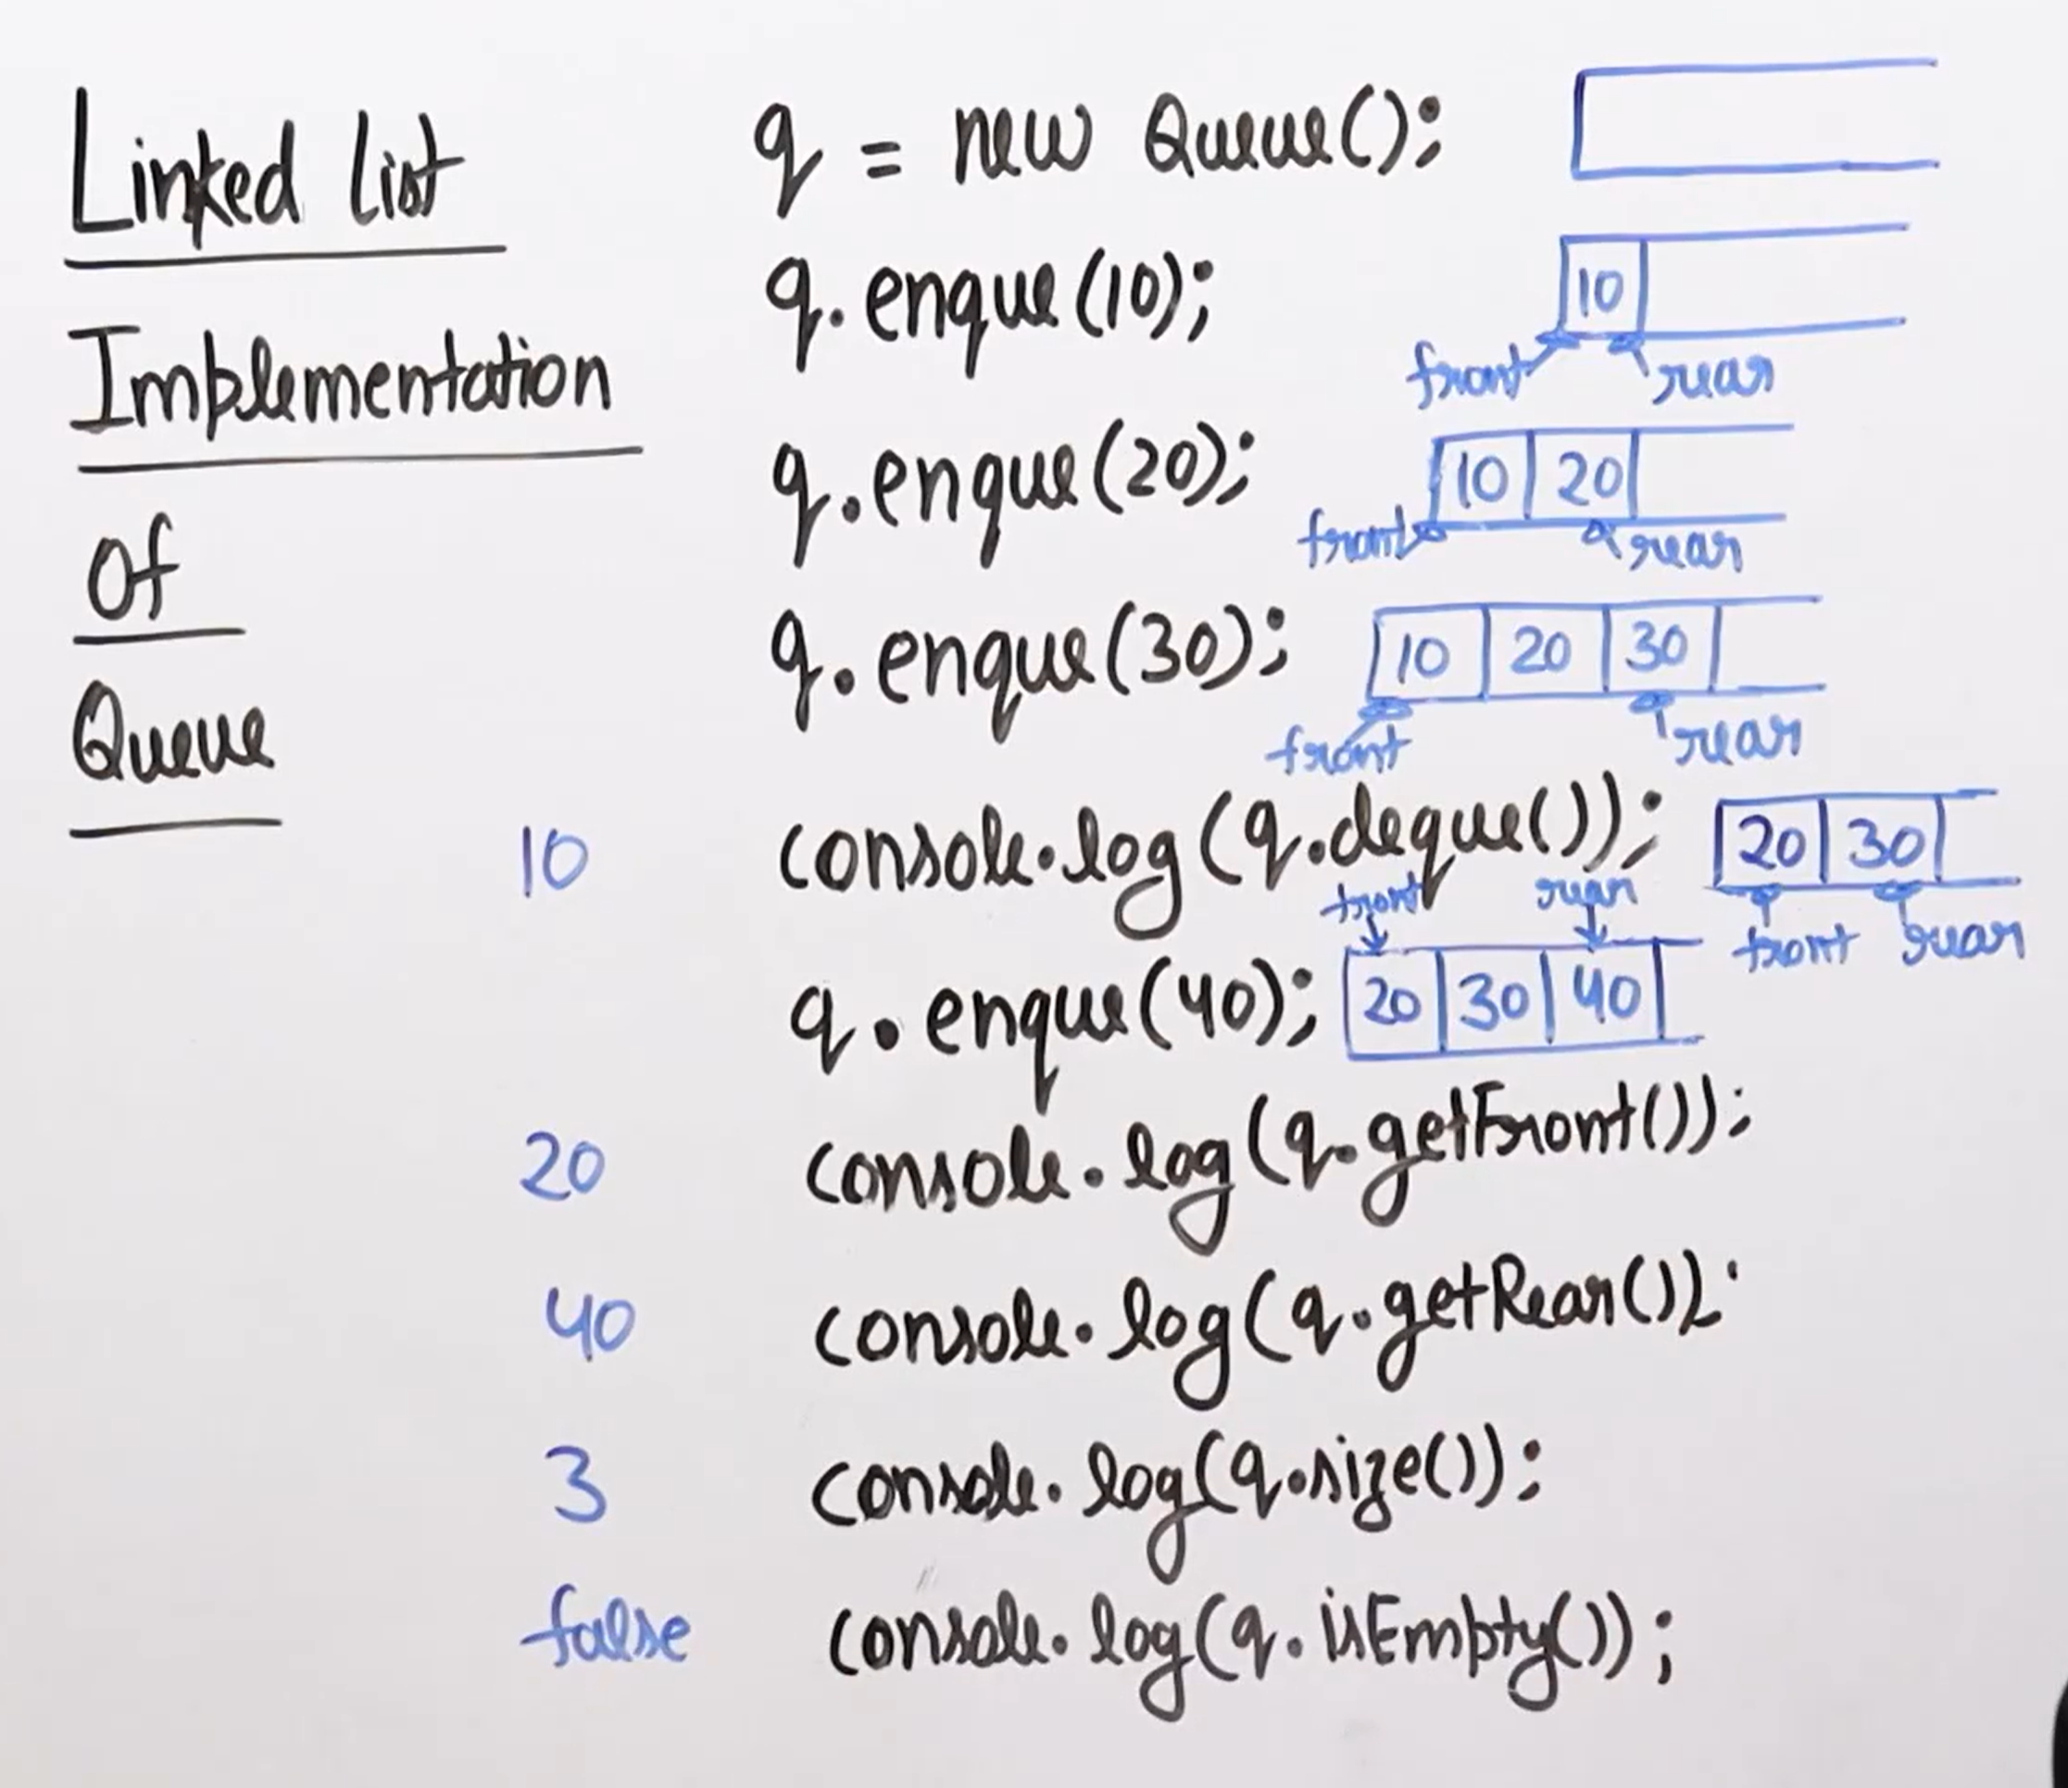
It is the wrong choice in the insertion is ok but, in the deletion, we need to travel till the front, so it is not the good choice.

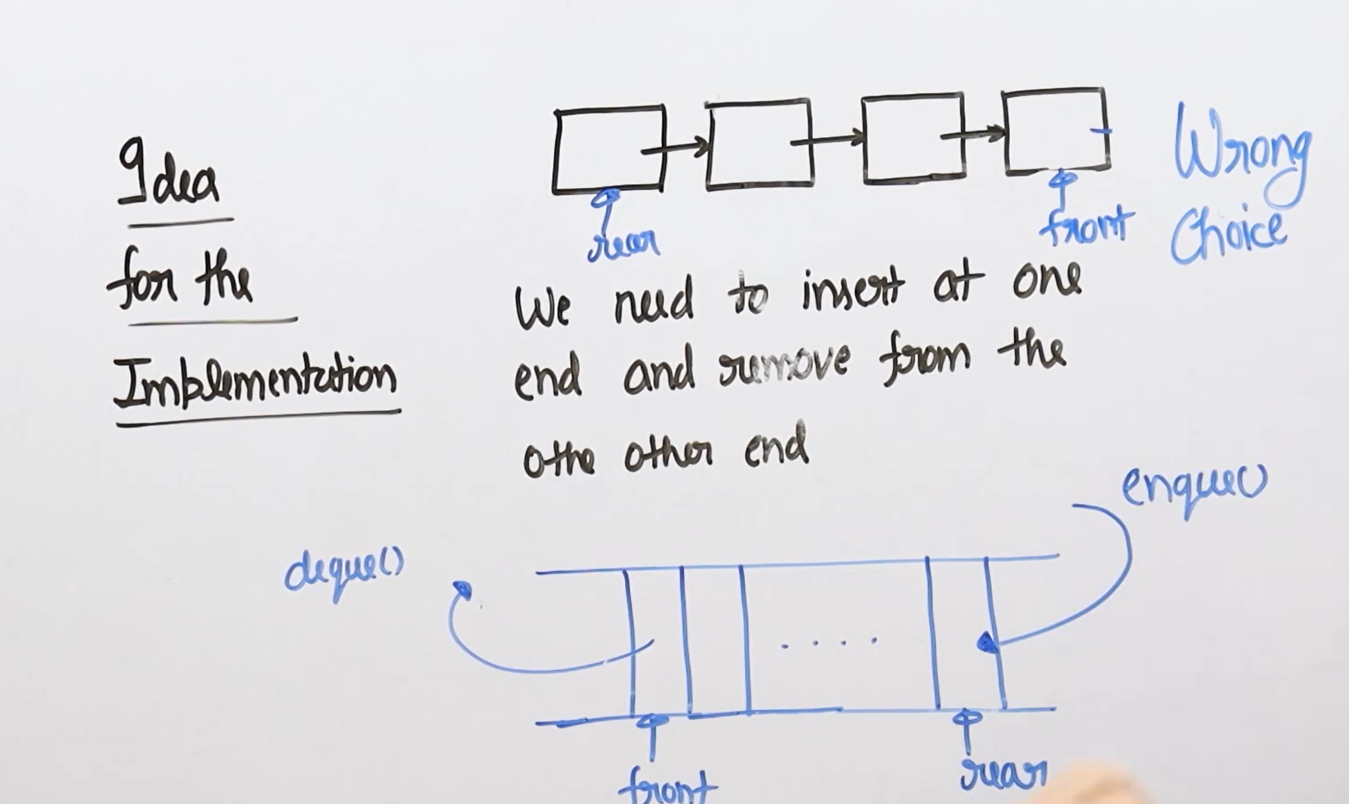
This is the correct approach u can see in the image.


